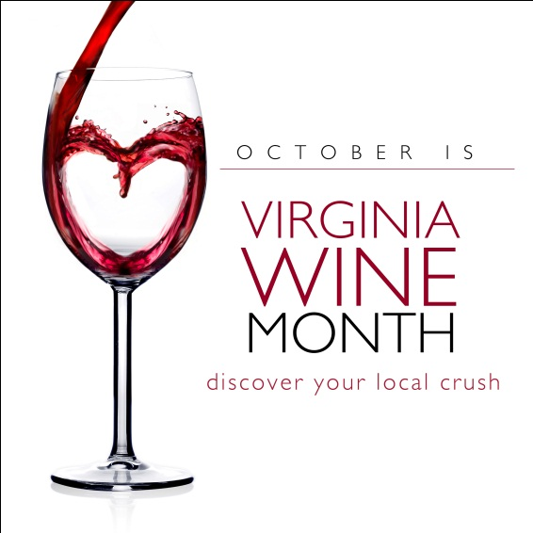

Trade Commitment Letter:
October Virginia
Wine Month 2011

Dear Virginia Wine Restaurateurs and Retailers:

By signing this form, you are committing to sell and promote Virginia wines for October Virginia Wine Month, October 1, 2011 through October 31, 2011. By committing to adhere by the below criteria, the Virginia Wine Board Marketing Office will in turn provide you promotional materials, such as POS, free of cost - in advance (please see attached POS Request Form) to help you better sell Virginia wines! In addition, we will heavily promote your business on our website VirginiaWine.org (which receives over 2.5 million page views annually) as a preferred partner. Restaurants and retail shops that sign up and participate will be included in in our press release information about October Virginia Wine Month. The deadline to return this completed trade commitment form in order to participate in October Virginia Wine Month and receive free POS is Friday, August 26, 2011.

Criteria for Restaurants:
For October Virginia Wine Month, I agree to sell at least 3 Virginia wines (Virginia appellation) by the glass and to promote these selections via my menu and / or blackboard specials.

Criteria for Retailers:
For October Virginia Wine Month I agree to sell at least 3 Virginia wines (Virginia appellation) by the bottle and to promote these selections through in-store tastings.

POS Request Form:

Please write in your requested quantity and return this form to our office, or email it to: MaryCatherine.Searson@Virginiawine.org, or fax it to 804‐344‐8332.

Please remit this signed commitment to our office (with applicable criteria checked off) no later than Friday, August 26, 2011. Forms can be mailed, emailed or faxed.

Establishment:
Address:
City: State: Zip:
Phone Number: Fax:
Email Address:
Website:
Point of Contact (please spell out):
Signature:

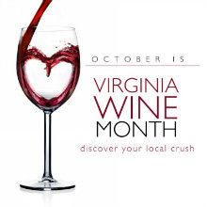

Available POS:

Bar Coasters – to set out around your bar, tables, counter tops
Quantity: (limit 125)
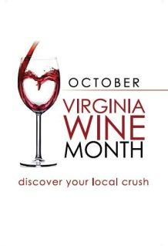
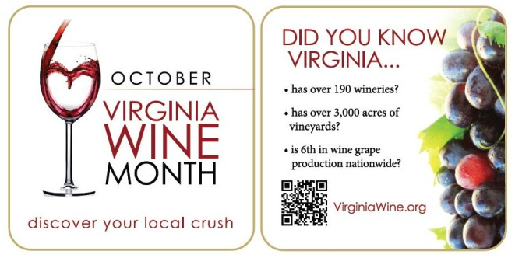

Case Cards – attaches to case box for a display of wine and the October Virginia Wine Month logo
Quantity: (limit 2)

Shelf Talkers – to be affixed to and hang down from a shelf
Quantity: (limit 5)

Bottle Bags – bags made for a bottle of wine to give to customers
Quantity: (limit 200)

Promotional Chalkboard – to be placed in your restaurant or retail shop
Quantity: (limit 1)
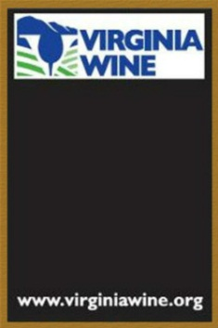

Please Note: If you already received a chalkboard from our office for a past promotion, then you cannot request another one for October Virginia Wine Month.

Buttons – rectangular buttons with the logo that you can distribute to staff and customers
Quantity: (limit 20)
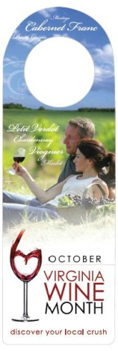
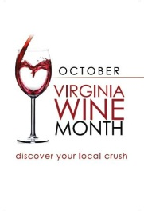
Note: Buttons come in bags of 5

Virginia Wine Key – to be used by staff for opening Virginia wine bottles
Quantity: (limit 3)

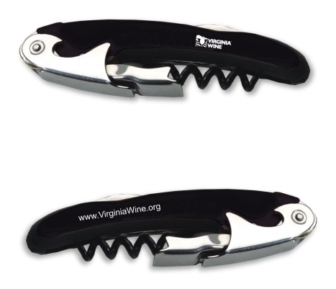

Bottle Neck Tags – to hang on the Virginia wine bottles in your display
Quantity: (limit 50)

Virginia Wine Poster – to hang in your restaurant or retail store
Quantity: (limit 1)

