*This meeting was held electronically via WebEx on Tuesday, May 5, 2020 during the Governor’s declared state of emergency due to the COVID-19 pandemic making it unsafe for the public body to assemble in a single location. A recording of the meeting is available:*

<https://covaconf.webex.com/recordingservice/sites/covaconf/recording/playback/8bbca4957a31480ab4124ebae5850df7> Password: Cx2uF3By

**Tuesday, May 5, 2020**

**Board Members Present**

Kirk Wiles, Chairman Mitzi Batterson

Doug Fabbioli Luca Paschina

Patrick Duffeler, II Megan Seibel

Tayloe Dameron Len Thompson

Courtney Mailey

**Guests / Staff**

Annette Boyd, Wine Marketing Office Melissa Ball, VDACS

Susan Kramer, Wine Marketing Office Memo Maquivar, VDACS

Anna Pendleton, Wine Marketing Office Caitlin Miller, VDACS

Megan Womack, Wine Marketing Office

George Hodson, Virginia Wineries Association

Laurie Aldrich, Virginia Wineries Association and Virginia Association of Cider Makers

Mary Beth Williams, Williams Compliance

Joy Ting, Winemakers Research Exchange

Emily Pelton, Winemakers Research Exchange

Corry Craighill, Loudoun Wineries Association

Peter Hoehn, Early Mountain Vineyards

Mizuho Nita, Virginia Tech

Tony Wolf, Virginia Tech

Greg Evanylo, Virginia Tech

Doug Pfeiffer, Virginia Tech

Beth Chang, Virginia Tech

Anton Baudoin, Virginia Tech

Sean O’Keefe, Virginia Tech

Ryan Stewart, Virginia Tech

Jaclyn Fiola, Virginia Tech

Jeffrey Derr, Virginia Tech

Karen Reed, VA Wine Consulting

Dan Reilly, SMS Research Advisors

Anna Salzburg, EEE Consulting, Inc.

Françoise Seillier-Moiseiwitsch, Revalation Vineyards

Lindsay Usher, Old Dominion University

Emily Yeager, East Carolina University

Suzanne McGrath, The New Ag School

Nancy Craun, Encore Event Partners, LLC

Summer Johnson, RIESTER Public Affairs

Mike Allen, Resonance, LLC

1. **Call to Order & Welcome** - 10:00 AM
2. **Financial Report -** Mitzi Batterson presenting
3. FY 2020: Base appropriations as of 7/1/2019 is 2,273,692.00. There is approximately 176,320.02 unallocated for the remainder of the 2019-2020 Fiscal Year.
4. FY 2021 Base Budget as follows (including the unallocated anticipated from FY 2020)

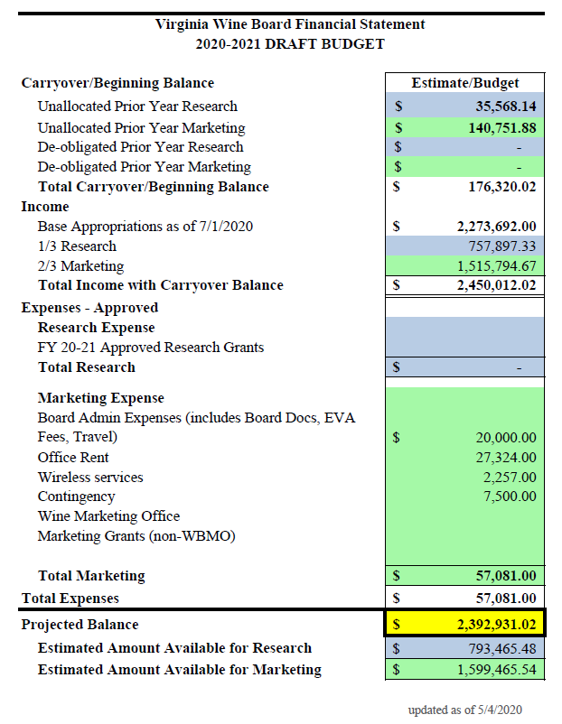

**III. Grant Extensions**

*A motion was made, seconded and unanimously approved to give the Wine Board Chairman the authority to make decisions on no-cost grant extensions up to 12 months beyond their original deadline.*

*A motion was made, seconded and unanimously approved to allow budget amendments for the two following grants:*

Dr. Tony Wolf & Dr. Mizuho Nita 2019-2020 “Establishment of Viticulture and Grape Pathology Research Vineyards”

|  |  |  |  |
| --- | --- | --- | --- |
| **Account Number/Subaward (449982)** | | | |
| **Category** | **Original Budget** | **Budget Change-- Add/Decrease** | **New Revised Budget** |
| Wage | $3,000.00 | ($3,000.00) | $0.00 |
| Fringe | $225.00 | ($225.00) | $0.00 |
| Materials and Supplies | $4,412.00 | $3,099.00 | $7,511.00 |
| Contractual Services | $1,000.00 | $0.00 | $1,000.00 |
| Equipment | $6,500 | $126 | $6,626.00 |
| **TOTAL** | **$15,137.00** |  | **$15,137.00** |
| **Re-budget highlight** | | | |
| Moved wage to materials and supplies | | | |
| **Re-budget justification** | | | |
| **Wage and fringe:**  We hired several temporary workers to remove wires, but was able to cover with another grant. | | | |
| **Materials and Supplies:** We needed more tools and other supplies for the field and lab. Also, we are purchasing consumables and tools (backpack sprayer, fungicides, a small mower, etc.) that can be used in 2020-21 season for this project. | | | |

Dr. Tony Wolf & Dr. Mizuho Nita 2019-2020 “Causes and Potential Management Tools for Macrophoma Rot”

|  |  |  |  |
| --- | --- | --- | --- |
| **Account Number/Subaward (449984)** | | | |
| **Category** | **Original Budget** | **Budget Change-- Add/Decrease** | **New Revised Budget** |
| Wage | $3,000.00 | ($3,000.00) | $0.00 |
| Fringe | $225.00 | ($225.00) | $0.00 |
| Materials and Supplies | $3,000.00 | $4,225.00 | $7,225.00 |
| Contractual Services | $1,000.00 | ($1,000.00) | $0.00 |
| **TOTAL** | **$7,225.00** |  | **$7,225.00** |
| **Re-budget highlight** | | | |
| Moved wage to materials and supplies | | | |
| **Re-budget justification** | | | |
| **Wage and fringe:**  Two part-time wage workers have been involved; however, we were able to cover them using other grants. | | | |
| **Materials and Supplies:** We are nearly done with the project, but I would like to repeat some of the experiments to have more robust data. I think we have enough left in this account so that we do not need to request extra. | | | |

1. **Wine Marketing Office FY 2020 Budget**

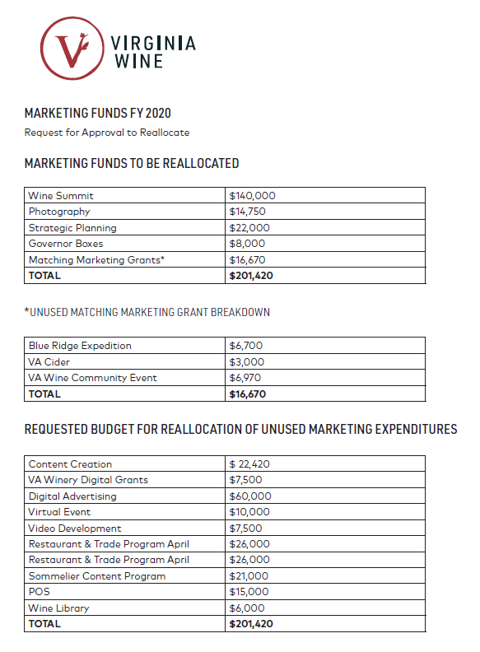 Annette Boyd presented a budget amendment to the Board that would allow the Wine Marketing Office to reallocate $201,420 from its current category to others that will be more impactful, given the current situation with the COVID-19 pandemic. *A motion was made, seconded and unanimously approved to approve the WMO budget reallocation as presented.*

1. **Wine Marketing Office FY 2021 Marketing Plan Proposal**

*A motion was made, seconded, and unanimously approved to fund the Wine Marketing Office proposal as follows:*



**VI. 2020-2021 Grant Program**

The Board reviewed 35 marketing, education and research proposals submitted for the 2020-2021 fiscal year.

*The Board voted unanimously to fund the following projects:*

|  |  |  |  |
| --- | --- | --- | --- |
| **Title** | **Organization** | **Lead** | **Amount** |
| Virginia Winemakers Research Exchange: 2020-2021 Experiments and Sensory Sessions | Winemakers Research Exchange | Joy Ting | $167,150 |
| Support for Virginia Vineyards Association Technical Meetings | Virginia Vineyards Association | Nate Walsh | $25,000 |
| Viticulture Extension and Research Support | Virginia Tech | Tony Wolf | $49,238 |
| Regulation Round-Ups and VWA Winery Resource | Virginia Wineries Association | Laurie Aldrich | $64,000 |
| Winter and Summer Education and Technical Programs 2020-2021 | Virginia Association of Cider Makers | Laurie Aldrich | $7,500 |
| Validate the efficacy of pre-release formulations of Rhizobium vitis ARK-1, a biological agent against crown gall of grape | Virginia Tech | Mizuho Nita | $52,000 |
| Spotted lanternfly affecting Virginia vineyards: Determination of expansion in vineyard areas, and chemical control agents of egg masses | Virginia Tech | Doug Pfeiffer | $56,836 |
| VWA Annual Meeting & Conference for 2020 | Virginia Wineries Association | Laurie Aldrich | $25,000 |
| GrapeIPM.org Phase 2: Grape disease management decision support system | Virginia Tech | Mizuho Nita | $18,000 |
| Enabling relationship building and knowledge transfer between industry stakeholders and enology extension personnel through in-person interactions | Virginia Tech | Beth Chang | $4,262 |
| Calibrating benchmarks for Virginia Grape and Wine using historic data sets | Winemakers Research Exchange | Joy Ting | $25,000 |
| Evaluation of alternatives to glyphosate for vineyard weed control | Virginia Tech | Jeffrey Derr | $27,000 |
| Governor’s Cup Seminar 2021 | Virginia Wineries Association | Laurie Aldrich | $15,000 |
| Establishment of Virginia sentinel vineyard network for extension and research | Virginia Tech | Mizuho Nita | $20,000 |
| Improving Soil Testing to Better Predict Potassium Availability in Vineyard Soils | Virginia Tech | Greg Evanylo | $13,168 |
| Mealybug species composition and management in Virginia vineyards | Virginia Tech | Doug Pfeiffer | $55,742 |
| Grape disease management projects | Virginia Tech | Mizuho Nita | $18,000 |
| Virginia Tech Commercial Grape Report | SMS Research Advisors | Dan Reilly | $35,900 |
| Maintaining fungicide resistance testing capabilities for grape diseases, and follow-up tests on cane-infecting fungi-II | Virginia Tech | Anton Baudoin | $8,400 |
| Viticulture Training for High-School Students | Revalation Vineyards | Françoise Seillier-Moiseiwitsch | $15,000 |
| Virginia Cooperative Extension assistance with identifying commercial vineyards | Virginia Tech | Tony Wolf | $14,000 |
| Virginia Winery Tasting Room Education & Training Program | The New Ag School | Suzanne McGrath | $24,190 |
| **Research Grants Approved** | | | **$740,386** |

|  |  |  |  |
| --- | --- | --- | --- |
| **Title** | **Organization** | **Lead** | **Amount** |
| Governor’s Cup Competition 2021 | Virginia Wineries Association | Laurie Aldrich | $110,000 |
| Governor’s Cup Consumer Event 2021 | Virginia Wineries Association | Laurie Aldrich | $40,000 |
| **Marketing Grants Approved** | | | **$150,000** |

**Total Grants:****$890,386**

*The Board voted unanimously to table the following project:*

|  |  |  |  |
| --- | --- | --- | --- |
| **Title** | **Organization** | **Lead** | **Amount** |
| Workforce Development – Bilingual Vineyard Workshops | Virginia Wineries Association | Laurie Aldrich | $20,000 |

*The Board voted unanimously not to fund the following projects:*

|  |  |  |  |
| --- | --- | --- | --- |
| **Title** | **Organization** | **Lead** | **Amount** |
| Develop methods for early detection and identification of grape pathogens in the environment and on plants | Virginia Tech | Mizuho Nita | $69,000 |
| Characterizing the Contribution of Topsoil to Virginia Wine Quality | Virginia Tech | Ryan Stewart | $29,231 |
| Characterizing the regional microbial terroir of Virginia wines and their effects on ambient fermentations | Virginia Tech | Beth Chang | $58,955 |
| Vineyard Incentive and Economic Development Collaboration | Resonance, LLC | Jennifer Goldman | $32,000 |
| Detection of grapevine downy mildew using an Unmanned Aerial Vehicle (UAV) mounted with a multispectral sensor | Virginia Wine Consulting | Karen Reed | $21,507 |
| Which can lining material is best for canned wines? | Virginia Tech | Sean O’Keefe | $18,534 |
| Analysis of Environmental Sustainability Marketing Efforts in Virginia’s Wine Industry | EEE Consulting, Inc. | Anna Salzburg | $52,745 |
| An analysis of short-term vacation rental hosts and guests and Virginia wine tourism | Old Dominion University | Lindsay Usher | $35,056 |
| Showcasing Our Roots: Expanding the Virginia Wine Industry’s Regional Market through the Culinary Cultural Experience | Encore Event Partners, LLC | Nancy Craun | $30,000 |
| The Official Wine Podcast of the Virginia Wine Country | RIESTER Public Affairs | Summer Johnson | $82,660 |

**VII. Public Comment**

None

**VII. Adjourn**

The meeting adjourned at 5:00 PM.