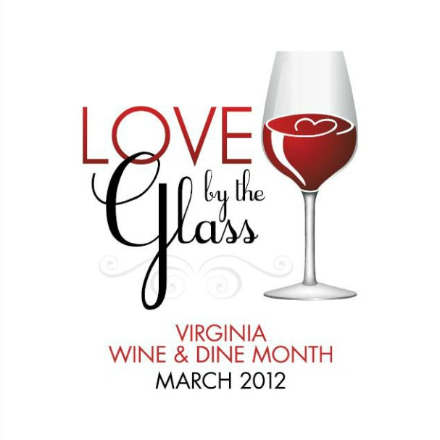

Trade Commitment Letter
Love By The Glass:
Virginia Wine & Dine Month

Dear Virginia Wine Restaurateurs and Retailers:

By signing this form, you are committing to sell and promote Virginia wines for Love By The Glass: Virginia Wine & Dine Month, March 1, 2012 through March 31, 2012. By committing to adhere to the below criteria, the Virginia Wine Board Marketing Office will in turn provide you promotional materials, such as POS, free of cost - in advance (please see attached POS Request Form) to help you better sell Virginia wines! In addition, we will heavily promote your business on our website VirginiaWine.org (which receives over 2.5 million page views annually) as a preferred partner. Restaurants and retail shops that sign up and participate will be included in in our press release information about Love By The Glass: Virginia Wine & Dine Month. The deadline to return this completed trade commitment form in order to participate in Love By The Glass: Virginia Wine & Dine Month and receive free POS is Friday, February 3, 2012.

Criteria for Restaurants:
For Virginia Wine & Dine Month, I agree to sell at least 3 Virginia wines (Virginia appellation) by the glass and to promote these selections via my menu and / or blackboard specials.

Criteria for Retailers:
For Virginia Wine & Dine Month, I agree to sell at least 3 Virginia wines (Virginia appellation) by the bottle and to promote these selections through in-store tastings.

POS Request Form:

Please write in your requested quantity and return this form to our office, or email it to: MaryCatherine.Searson@Virginiawine.org, or fax it to 804‐344‐8332.

Please remit this signed commitment to our office (with applicable criteria checked off) no later than Friday, February 3, 2012. Forms can be mailed, emailed or faxed.

Establishment:
Address:
City: State: Zip:
Phone Number: Fax:
Email Address:
Website:
Point of Contact (please spell out):
Signature:

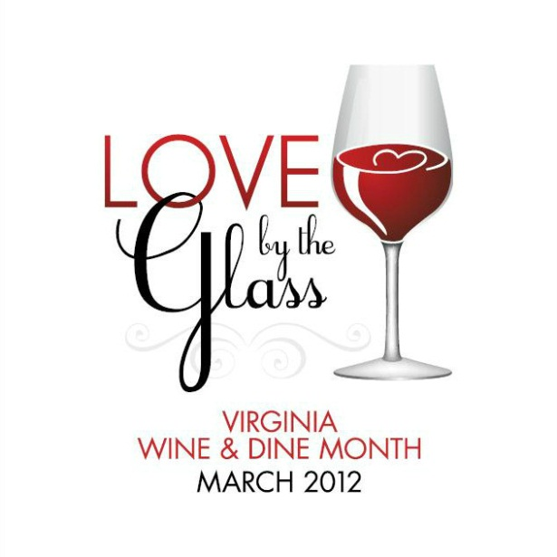

Available POS:

Bar Coasters – to set out around your bar, tables, counter tops
Quantity: (limit 100)
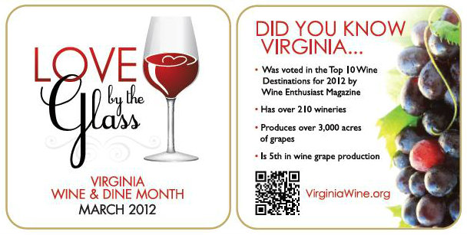

Case Cards – attaches to case box for a display of wine and the Virginia Wine & Dine Month logo
Quantity: (limit 2)
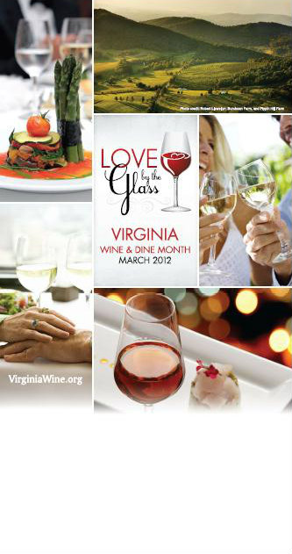

Shelf Talkers – to be affixed to and hang down from a shelf
Quantity: (limit 5)
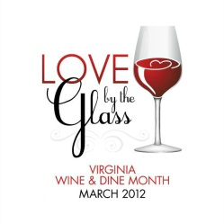

Bottle Bags – bags made for a bottle of wine to give to customers
Quantity: (limit 100)

Promotional Chalkboard – to be placed in your restaurant or retail shop
Quantity: (limit 1)
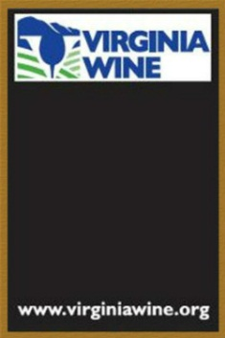

Please Note: If you already received a chalkboard from our office for a past promotion, then you cannot request another for Virginia Wine & Dine Month.

Buttons – circular buttons with the logo that you can distribute to staff and customers
Quantity: (limit 20)
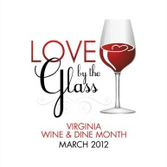
Note: Buttons come in bags of 5

Virginia Wine Key – to be used by staff for opening Virginia wine bottles
Quantity: (limit 2)

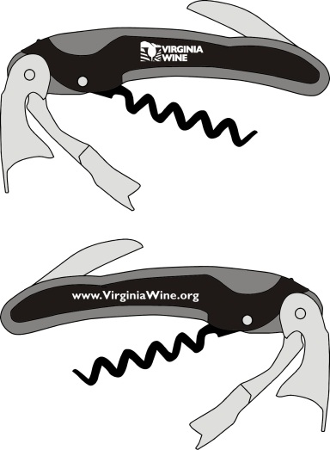
Bottle Neck Tags – to hang on the Virginia wine bottles in your display
Quantity: (limit 25)
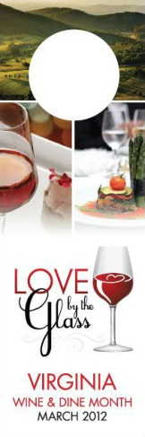

Virginia Wine Poster – to hang in your restaurant or retail store
Quantity: (limit 1)

