Submitted to the
Virginia Wine Board

Final Report – Submitted October 3, 2014
Final Report
Spotted wing drosophila in Virginia vineyards: Distribution, varietal susceptibility, monitoring and control Douglas G. Pfeiffer
Department of Entomology, Virginia Tech, Blacksburg, VA 24061

D. Objectives:
This project addresses a new invasive pest, spotted wing drosophila (SWD), an insect that is having a dramatic impact on berry and vineyard crops in much of the U.S. The current project is expanded to include a further invasive species we found in Virginia for the first time, African fig fly (AFF).
The specific objectives are:

- Determine abundance and seasonal phenology in vineyards in Virginia
- Determine varietal differences in severity of infestation,
- Determine efficacious chemical control tactics,
- Comparing apple cider vinegar traps with a dry chamber model (Modified to: Optimizing readily available trapping systems for SWD).

E. Background: Spotted wing drosophila, Drosophila suzukii (Matsumura), is a congeneric relative of other vinegar or pomace flies (popularly called fruit flies). This species is native to eastern Asia. It was introduced into California in 2008. During 2009, it spread up the Pacific Coast through British Columbia. Late in 2009, it was found in Florida. Because of the speed with which it moved up the west coast, we established a trapping program in South Carolina, North Carolina and Virginia in 2010. At that time, SWD was detected in both Carolinas but not Virginia; however, it was found in all five trapping locations in Virginia in 2011 (Pfeiffer et al. 2011, Pfeiffer et al. 2012). In the first year of this project (2012), we found SWD wherever we trapped (Pfeiffer 2012); it should now be considered generally distributed in the state (Fig. 1).
Unlike other Drosophila species, SWD attacks ripening fruit on the plant, not limited to overripe fruit material. SWD has a large, toothed ovipositor with which it cuts through healthy, intact fruit skin. Each female can lay 7-16 eggs per day, with an adult life span of up to 9 weeks. There are about 13 generations per season. Larvae develop and feed in the fruit tissue, causing a premature softening with tissue breakdown.

Fig. 1. Collection counties for spotted wing drosophila in Virginia, as of October 2014.

Monitoring may be accomplished using apple cider vinegar traps. These may be easily constructed using plastic deli cups with holes made near the top lip. SWD (along with other drosophilid species) are attracted to the ACV, and are collected in the fluid. Since the trap is not specific for SWD, adults must be filtered from the ACV and returned to the lab for identification. Our trapping originally included yeast with the vinegar bait, because it was thought that this might increase attractancy to the adult flies. There was no significant benefit, and the mixture was opaque, making it impossible to see flies, and malodorous. In 2012 we tried three commercially prepared formulations of fruit essence (plum, sweet cherry and tart cherry). While these attracted SWD, they were not as attractive as ACV in our traps. In 2013, we improved collection by more frequent replacing of the fruit essence (using only plum). The most attractive bait was a 60:40 blend of red wine and ACV.

We reared SWD from winegrapes starting after véraison (Fig. 2). Preliminary analysis in 2012 indicated that red varieties may be at greatest risk. With experience in 2013 and 2014, it now appears that white varieties are also at risk.
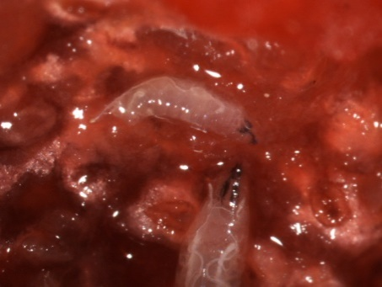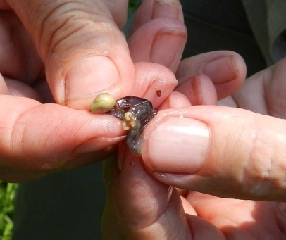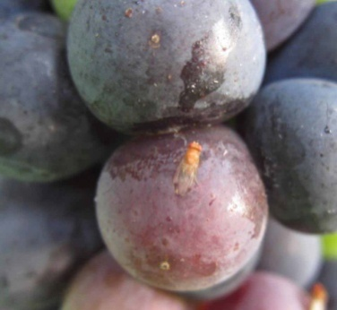
Fig. 2a. Spotted wing drosophila larvae in raspberry, b. Larvae in Pinot Noir grape, c. Adult on Pinot Noir cluster (note oviposition puncture in berry above the fly).

Fruit are mainly attacked during the ripening process. It is therefore critical to provide control of sensitive crops in the period shortly preceding harvest. It is important not merely to provide efficacy, but material must also be labeled with a short Preharvest Interval (PHI). Several materials with varying modes of action are listed in the 2014 Virginia Tech Pest Management Guide (Pfeiffer et al. 2014). However, research needed to determine actually control provided in the field. Some likely pesticides for SWD were listed by Walsh et al. (2011). With the high number of generations and high reproductive capacity of SWD, there is high risk of insecticide resistance. Such resistance already appears to have developed in California after repeated applications of pyrethrins, even when SWD adults were exposed to twice the label rate (Bolda 2011). To mitigate the development of resistance, part of a pest management program should be a selection of insecticides of differing modes of action, which can be rotated by the vineyard manager.
In the course of our first year work, we found a new invasive drosophilid infesting grapes in commercial vineyards, the African fig fly (AFF), Zaprionus indianus Gupta (Pfeiffer 2012). In some cluster samples retrieved to the lab for rearing, 90% of the flies were AFF. The role of AFF in grape quality is currently being addressed.
In our initial studies, red varieties appeared at greater risk than white; white varieties were also attacking in 2013 and 2014. Varietal comparisons will be expanded. In some thin-skinned varieties, high infestation levels were seen (up to one larva per four berries; this is erratic howeverIn the early years of infestation, fruit workers in the west were under the impression that grape is not at risk. However, recent observations have revealed infestations with about 5% of berries in a cluster infested (Walton personal communication). SWD may be favored in the mid-Atlantic region by higher humidity and greater rainfall than in western viticultural areas.

Progress:

- Determine abundance and seasonal phenology in vineyards in Virginia:
In the 2013 and 2014 seasons, we modified our understanding of the beginning of attack. Our initial understanding was that attacks may begin at veraison; this would be consistent the situation in blueberries and caneberries. However SWD did not begin ovipositing this early. Infestations began when berries reached about 15° Brix. Populations in 2014 were delayed throughout the eastern US because of our unusually cold winter. This delayed some of our projects, but populations eventually did build as we were able to work on our objectives. The pattern of oviposition starting about 15° was supported.

- Determine varietal differences in severity of infestation:
In the late summer and fall of 2012 several grape growers were experiencing problems with Drosophila suzukii, also known as the spotted wing drosophila (SWD), infesting their thin-skinned red grapes. Several theories evolved as to why the SWD would seemingly be more attracted to these varieties. Such differences could arise from the skin thickness allowing for easier oviposition by the fly or elevated sugar levels in the red varieties. Another factor might be that the red grape varieties were the only grapes left in the field when SWD population reached high levels. In order to ascertain if the SWD has an affinity for red thin-skinned grapes a varietal preference test including both choice and non-choice experiments was conducted in the late summer / fall of 2013.

Materials and Methods
The varietal preference testing included six different varieties of wine grapes. The varieties selected included; Petit Manseng, Petit Verdot, Vidal, Viognier, Cabernet Franc, and Pinotage. Field-collected clusters of each variety came from a single vineyard located in the Piedmont region (Orange County) of Virginia. Testing was conducted weekly for four weeks starting just after véraison. Clusters were collected, ice-cooled and transported back to Blacksburg for testing in the laboratory. Testing began within 24 hours after grape clusters were removed from the field. We conducted three weeks of experiments with both choice and non-choice tests. The choice test consisted of 12 replicates and four replicates each of the non-choice test for each week.

We tested for varietal preferences using a constant mass of 20 grams of grapes for each of the six varieties. Individual grapes along with the stem were cut from the cluster using scissors to avoid exposing the grape flesh. If grapes were picked off the cluster the area where the pedicle attached would be a prime oviposition spot due to the exposed flesh of the grape. Grapes were weighed individually so an approximate number of grapes per sample could be calculated in case grape size was a factor in SWD infestation. Other factors to be evaluated were skin color, skin thickness, penetration force, and degrees Brix at the time of testing. Skin thickness was measured with a digital caliper measuring micrometers. Degrees Brix were determined by pressing the juice from a 30g sample of grapes and placing the juice on a refractometer. Penetration force was measured in centi-newtons and was accomplished by placing a dulled insect pin on a piece of cork that was then attached to the centi-newton gauge. The pin was then pressed onto the grape skin until it punctured the surface of the grape.

Choice testing involved placing each of the six varieties of grapes into a 0.30 m³ collapsible mesh cage in a randomized pattern. Grape varietal position within the cages was noted and randomized for each experiment date. Fifteen male and female SWD flies of breeding age were placed into the mesh cage with the grapes. Fruit were exposed to flies for a 4-hour period and removed (Figure 3). Grapes were placed into plastic rearing cups and observed for a 21-day period. Emerging flies were collected, counted and identified. The non-choice testing was performed with the same methodology except only a single grape variety was placed in each cage. Field populations of SWD were also observed by collecting 10 g samples from three random locations within the sampled block of grapes. These grapes were then held for 21 days and all flies were collected counted and identified. Emergence of SWD from these clusters was low and field level infestations of SWD were not accounted for when analyzing the data. All data were analyzed using an ANOVA and a Tukey-Kramer test was used to separate the means.

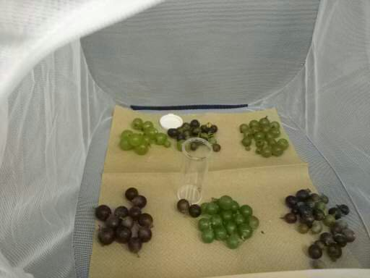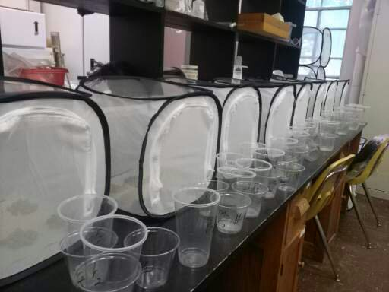
Figure 3. Picture of laboratory cage setup and rearing cups that were used in the varietal preference / survivorship testing.

Results
There was no statistically significant difference found among adult emergence from the six varieties of grapes tested after the data from the choice test were analyzed (P > 0.6701, df= 5, F= 0.6391) (Table 1 and Figure 4). Blocking by date was not significant when looking at the number of adult SWD that emerged from the grapes (P > 0.177, df= 2, F= 1.7418). The six varieties had statistically significantly different penetration forces (P < .0001, df = 5, F = 124.27), skin thicknesses (P < .0001, df = 5, F = 173.54) (Table 2), ad degrees Brix (P < .0001, df = 5, F = 104.67) (Table 3). Skin color was not statistically significant when comparing adult SWD emergence between red and white skinned grapes (P = 1.0, df = 1, F = 0). Data were blocked by date, which was a significant factor for all the aforementioned parameters. Among the non-choice test more adult SWD emerged from the Petit Manseng and Viognier varieties numerically, but no statistically significance was found (Table 1).

Table 1. Meanª emergence rate in laboratory no-choice and choice assay of grape varieties (20 g of fruit per variety)
Variety | Adult SWD emergence (no-choice, laboratory) | Adult SWD emergence (choice, laboratory)
Petit Manseng | 0.94 (±0.60)a | 0.38 (±0.20)a
Petit Verdot | 0.25 (±0.25)a | 0.81 (±0.35)a
Viognier | 1.13 (±0.47)a | 1.1 (±0.36)a
Vidal | 0.06 (±0.25)a | 0.47 (±0.25)a
Cabernet Franc | 0.31 (±0.31)a | 0.18 (±0.06)a
Pinotage | 0.38 (±0.26)a | 0.72 (±0.25)a
F | 1.97 | 0.6391
P | 0.09 | 0.6701
df | 5, 90 | 5, 215
ªValues within a column followed by the same letter are not significantly different (α = 0.05, Tukey-Kramer adjustment)

Table 2. Meanª measurements taken from a 24-grape sample from each of six varieties of grapes.
Grape Variety | Penetration Force (Cnw) | Skin Thickness (mm)
Petit Manseng | 19.85 (± 0.46)a | 0.172 (± 0.005)a
Petit Verdot | 15.79 (± 0.44)c | 0.089 (± 0.003)e
Viognier | 14.68(± 0.33)d | 0.127 (± 0.004)c
Vidal | 18.16 (± 0.38)b | 0.143 (± 0.004)b
Cabernet Franc | 16.37 (± 0.50)c | 0.106 (± 0.003)d
Pinotage | 17.90 (± 0.42)b | 0.144 (± 0.004)a
ªValues within a column followed by the same letter are not significantly different (α = 0.05, Tukey-Kramer adjustment)

Table 3. Degree Brix by date from a 30 g grape sample.
Grape Variety | August 30 | September 7 | September 14 | September 23
Petit Manseng | 12.3 | 15.6 | 22.8 | 18
Petit Verdot | 13.6 | 15.4 | 20.4 | 16
Viognier | 15.6 | 19.2 | 23.2 | 21.8
Vidal | 13.8 | 16 | 16 | 15
Cabernet Franc | 14 | 13.2 | 16.2 | 19.2
Pinotage | 19.1 | 17.2 | 24.2 | 23.2

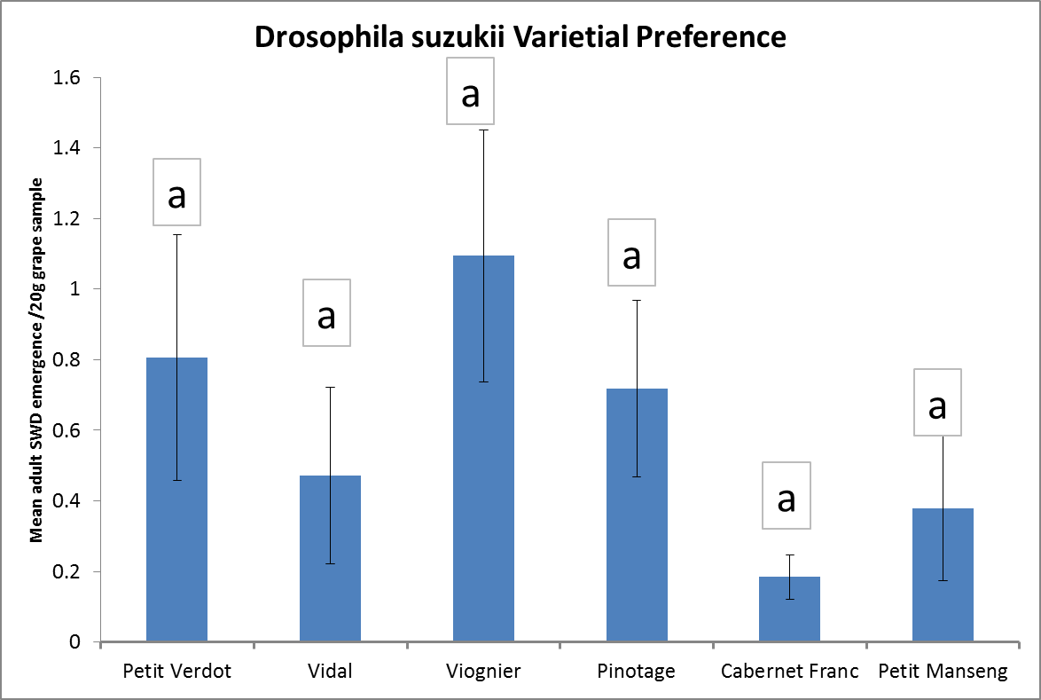
Figure 4. Mean number of adult SWD that emerged from a 20g grape sample in a laboratory choice test. No variety had statistically significantly different adult SWD emerge from the grapes.

Discussion
There was no preference / survivorship difference among the six varieties tested in the lab for adult SWD emergence. There was also no statistical significance in the non-choice test. A possible explanation for this non-preference and low survivorship in grapes is the Brix in all the varieties was not desirable early on in the testing. Female flies may desire Brix to be at a certain degree before ovipositing. Flies may avoid fruit with low sugar levels because the levels may not be high enough to support yeast growth for larval survival. There was little or no emergence from the grapes until the brix reached 15 degrees. After the Brix threshold of 15° was met, several varieties in the non-choice test had SWD emerge. During the 2nd and 3rd weeks of testing when all varieties in the choice test had reached the sugar threshold there still was no varietal preference or difference is larval survivorship. Another explanation for this non-preference and low survivorship is the number of SWD to emerge in testing was not high enough to exhibit any statistical significance. Figure 2 and Table 1 show low levels of emergence from all varieties. An additional factor that might have affected oviposition rates was the time of day the experiments were performed. The tests were executed from 10 AM until 6 PM in the evening. Drosophila that are observed outside have a strong bimodal laying period with early morning and evening being the preferred oviposition time. However, lab reared colonies do not exhibit such a strong activity pattern due to the static light and dark periods in a rearing chamber. It is possible that SWD might have exhibited some bimodal activity, despite being lab reared, so our 10AM start time may have missed the optimal period for egg laying. Another factor influencing SWD emergence from grapes was the period of time they were exposed to the host fruit. The four hour exposure period may not have been long enough for flies to orient to the fruit and oviposit eggs into the grape. Overall any statistically significant characteristics need to be scrutinized due to the low SWD emergence. This summer (2014) a longer oviposition period of 24 hours may increase SWD oviposition and adult emergence from grapes and give a more powerful test for varietal preference and survivorship. Preliminary data indicate this to be the case, and analysis is pending.

- Determine efficacious chemical control tactics:
In 2013, two chemical control trials were performed that failed to generate useful data. In the vineyard trial, populations remained low despite a high population of both SWD and AFF in the previous year. In a caneberry trial at Kentland Farm, numbers were so high that there were not treatment effects.
In 2014, two chemical control trials were executed. Data are still being analyzed, and the harvest data will be included in the next report. In summary, a new insecticide with great promise against SWD was included. Exirel (cyantraniliprole, DPX-HGW86) has been effective in other crops, but is not registered in grape. Currently the price of this product is high, and we examined the effectiveness of decreasing the application rate while adding a feeding stimulant, Monterey Bait. Induce non-ionic spreader-sticker was included. Preliminary examination of the data indicates that addition of a feeding stimulant may allow application of cyantraniliprole at a lower rate (Table 4).

Table 4. Infested grape berries following a control trial in Amherst County comparing two rates of DPX-HGW86 (cyantraniliprole), with the addition of a feeding stimulant.
Sample Date |  | 8/19 | 8/27 | 9/2 | 9/9 | 9/12
DAT |  | 6 | 8 | 6 | 7 | 3
Brix |  | 16.9 | 18.4 | 20.3 | 21.2 | 21.9
DPX 8 oz  Induce |  | 0 | 0 | 1.1 | 3.8 | 6.7
DPX 4 oz  Induce  Monterey |  | 0 | 0 | 2.9 | 7.9 | 8.8
DPX 8 oz  Induce  Monterey |  | 0 | 0 | 0 | 7.9 | 7.4
Control |  | 0 | 0 | 1.9 | 18.0 | 17.2

- Optimizing readily available trapping systems for SWD:
There have been several attempts to find an SWD attractant that would allow growers to quantify the SWD populations in the field based on trap counts. Currently the standard apple cider vinegar trap (ACV) is a qualitative tool. Several other baits such as yeast, wine + ACV, acetic acid and ethanol have been evaluated by Cha et al. (2012) and Landolt et al. (2012) with limited success in the field. However, these chemicals are all fermentation volatiles. The SWD is attracted to ripening fruit not necessarily to overripe or rotting fruit the use of fruit volatiles, especially those from ripe fruit would seem to be a better choice for use as bait. That is why we selected the scent of a plum to be used as an attractant in vineyards. This plum attractant should be more desirable than the fermentation products normally used and is presented in a commercially available sachet.

Materials and Methods
All trapping data were collected in two vineyards in the Piedmont region of Virginia. Since Petit Verdot grapes had been a severely infested variety the previous season the traps were placed in this variety alone. Traps were set up at location one on 29 August 2013 and at location two on September 6, 2013. Traps were checked weekly for 4 weeks at one location and for 3 weeks at the second location. Traps consisted of a plastic deli cup with eight 0.6 cm holes around the top of the cup. The baits selected for this trial included the standard ACV, ACV + Merlot (60/40 mix), yeast, plum essence sachet from Alpha Scents and a blank consisting of low-toxicity antifreeze. The yeast traps were changed weekly so a fungal mat would not hinder fly capture. The plum traps had the plum sachet changed weekly and used a trapping liquid of low-tox antifreeze. The ACV and ACV/Merlot mix was changed biweekly. All trapping liquids had a drop of liquid dish soap added as a surfactant that would break surface tension allowing for optimal trapping. Traps were hung in the canopy of the grape vines and checked weekly for flies. The traps were randomized in the field weekly. Four replicates were evaluated at location one and three replicates were evaluated at location two. All flies were collected in the field and then counted and identified in the lab in Blacksburg

Results
Data were analyzed using an ANOVA and a Tukey-Kramer test was used to separate the means. Blocking by location could not be done due to the uneven replicates for the sites. However, there seems to be a significant difference in the total number of flies captured between the two sites numerically. Trapping pressure was not high at either location, but the second site had fewer flies captured compared to site 1. The ACV + Merlot mixture attracted significantly more SWD when male and female SWD were combined (P < 0.0024, df= 3, F= 5.1598) (Fig. 5). When analyzed by sex the females were equally attracted to the ACV + merlot mix, yeast and plum. With an average of 27, 19, and 18 female flies being captured per trap respectively (P< 0.0117, df= 3, F= 3.3866) (Figure 6). The males were attracted more to the ACV + Merlot mix with an average of 14 males per trap (P< 0.0001, df= 3, F= 7.853). There was also a significantly greater number of other drosophilid flies attracted to the ACV + Merlot mixture, ACV and plum with an average of 46, 39 and 35 other drosophila captured respectively per trap (P< 0.0325, df= 3, F= 3.0454). This extra by-catch was a hindrance when trying to count, sex and separate all the flies in the traps. This also shows that the wine mixture was not specific to attracting SWD. The trap trial also showed that ACV was the least preferred bait for the SWD with all other baits being more attractive. When data were analyzed by location, site 1 female SWD found all baits equally attractive except the ACV, which was the least preferred of all the baits, while males found all other baits except ACV + wine desirable (Figure 7). At location two, both males and female SWD preferred the ACV + wine bait over the alternatives (Figure 8). Trapping for the 4-week period can be seen in Figures 9 and 10, where mean adult SWD numbers decreased in all baits except those with the ACV + wine mixture. The plum sachet remained consistently desirable at location 1 even when other trapping numbers decreased for the yeast bait and was statistically similar to the wine + ACV bait.

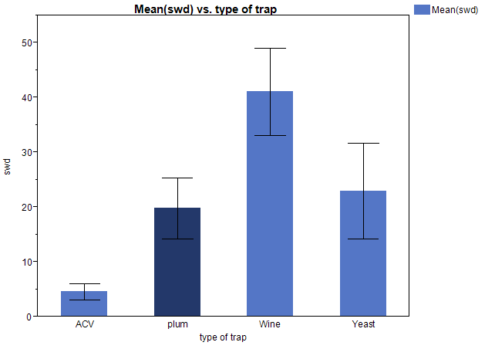
Mean Adult SWD / trap
AB
A
AB
B
Figure 5. Mean SWD adults (males and females combined) caught in traps for both locations. (“Wine” denotes the ACV + Merlot mixture)
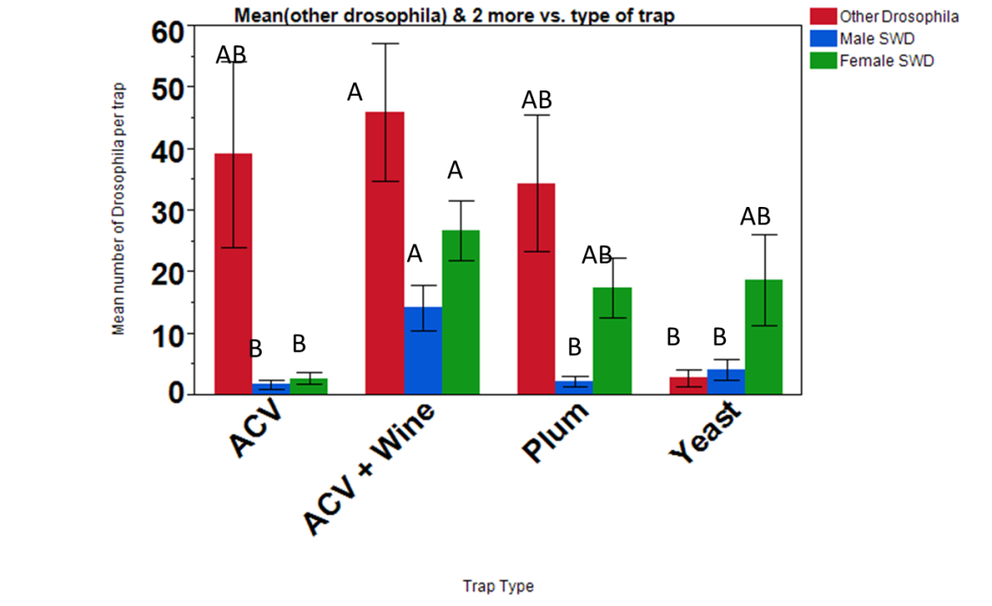
Figure 6. Mean number of Drosophila caught per trap from both locations combined with male and female SWD and other Drosophila in separate columns.

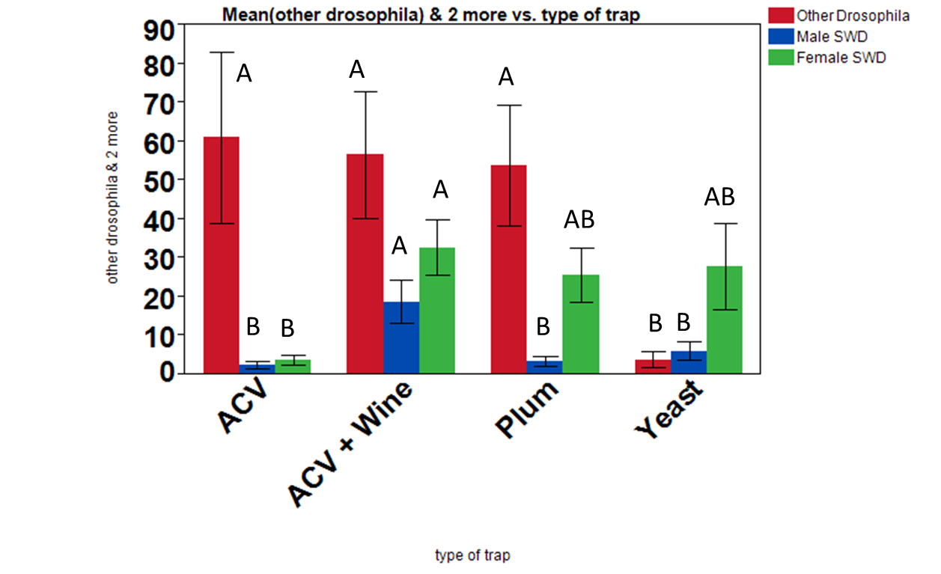
Mean number of Drosophila per trap
Figure 7. Mean number of other adult Drosophila and adult SWD male and female flies per trap from location one in Orange County Virginia.

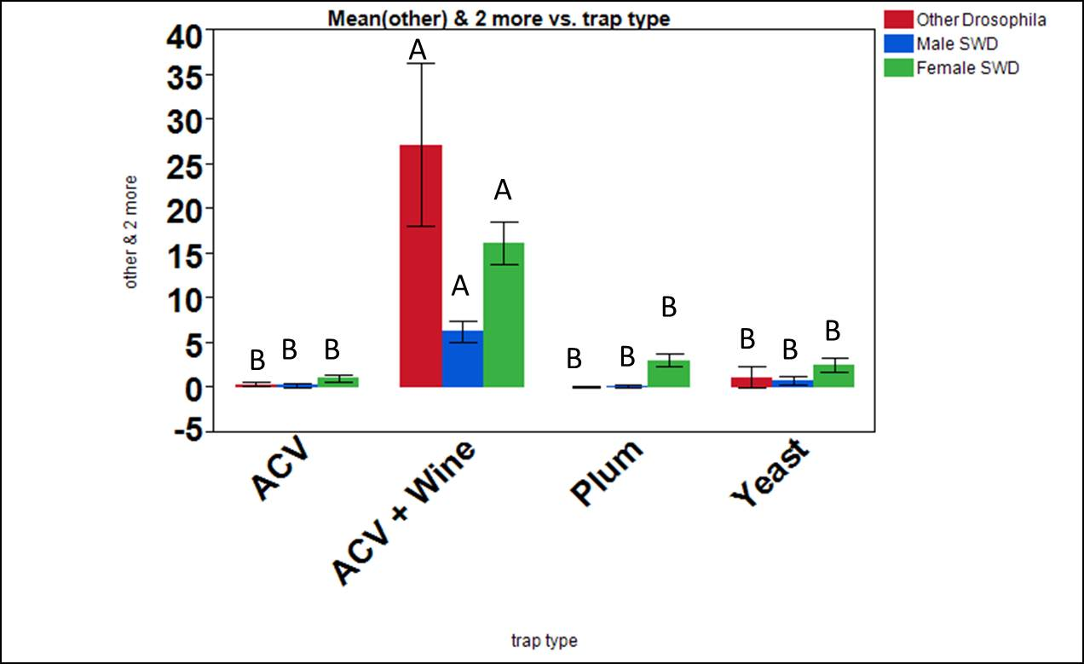
Mean number of Drosophila per trap
Figure 8. Mean number of other Drosophila and adult SWD male and female flies per trap from location 2 in Charlottesville, VA.

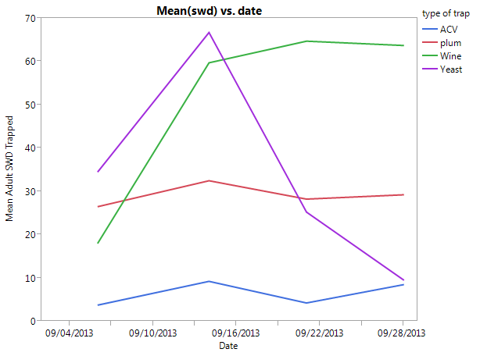
Grapes in next block picked
Figure 9. Mean adult SWD trapped using ACV, ACV + Merlot (wine), yeast and plum sachet baits over 4 weeks at location one.
Location 1
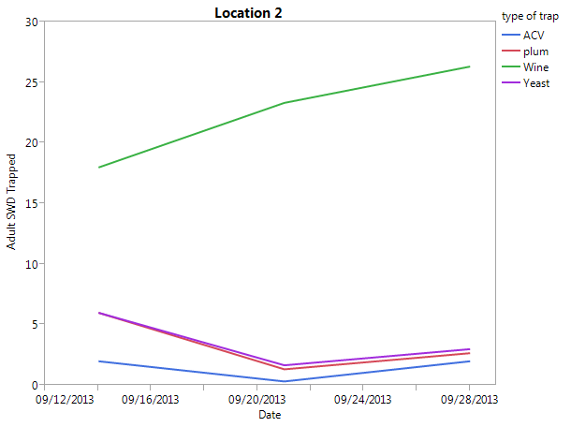
Figure 10. Mean adult SWD trapped using ACV, ACV + Merlot (wine), yeast and plum sachet baits over 3 weeks at location two.

Discussion
These results were similar to those of Cha et al. (2012), who they showed the ACV + Merlot mixture was significantly more attractive to SWD than all other fermentative volatiles they tested. An important finding from this trapping trial is that the plum, ACV + Merlot and yeast traps were all statistically similar for female flies when separated out by sex (Fig. 6). The female flies are the economically important sex and it is more important to get accurate trap numbers for them and be able to correlate these numbers to populations in the field. The plum sachet was just as attractive as the wine + ACV, which suggests that a fruit scent can be used to trap SWD and possibly pull them off of the grapes and into a trapping system (Figure 9). The preference for the wine + ACV and plum baits becomes more clear in location one when grapes started to be harvested from the field around week 3 of the experiment. Future traps will use the ACV + Merlot mixture as the new standard for trapping SWD in grape fields. Traps may include other fruit scents as well as plum. The plum sachets are commercially available and easy to use. They are statistically similar to the ACV and Merlot mixture and are not fermentative volatiles, which is unique for the baits being tested for SWD trapping. Yeast will most likely be left out due to the high maintenance, difficult trap counts and unpleasant smell. These are the only traps being deployed in a vineyard setting, which gives robustness to the baits used when compared across several trapping environments and fruit cultivation settings. While still not as attractive as the grapes themselves we are getting closer to developing baits that will be more quantitative instead of qualitative in field settings.

- Additional work on alternative hosts:
The SWD attacks several cultivated host plants including caneberries, strawberries, blueberries and grapes. The SWD also uses non-cultivated crops when these preferred cultivated crops are not available. Some non-cultivated crops include wild caneberries, poke weed, wild rose hips and several other fruiting plants. If we could identify all essential host plants needed for SWD population build up in the spring we could then remove them from the landscape. This would be especially important when cultivated crops are sprayed, these alternative plants may act as an unsprayed harborage for the SWD. Then once sprays have dissipated they can then move back into the cultivated crop. This removal of essential host plants from the immediate areas surrounding cultivated crops could possibly keep SWD populations lower for longer in these areas. In order to ascertain what wild host plants the SWD are using we collected plant samples from four geographically distinct areas.

Materials and Methods
The four distinct vineyards where samples were collected can be described as: 1. Small vineyard located in a forest clearing surrounded by woods. 2. Large vineyard near apple production and a wooded boarder with two grass boarders. 3. Small vineyard with wooded border and a grass pasture with cattle. 4. Large vineyard with soybean fields, some grassland and patchy wooded areas. Biweekly plant samples were collected from each of these locations. Plant samples were collected, labeled and their collection site marked with a handheld GPS device. Plant samples were then taken back to the lab at Blacksburg where they were identified and monitored for 14 days. This period of time should be long enough for larvae, pupae or adults to emerge from the plant samples. Any flies that emerged were collected, identified and placed in alcohol vials. Plants that had flies emerge were noted and kept in a log book and any seasonal plant preferences were noted.

Results
Over 390 plant samples were collected from May to mid-October when frost occurred (Table 5). There were 24 plant families represented in these samples (Table 6). Any plant that had a nectar source or fruiting body was collected. There were only three families in 2013 that were identified as being host plants, these were; Rosaceae, Phytolaccaceae, Caprifoliaceae. Specific plants that had adult flies emerge are wild blackberries, mock strawberries, pokeweed, and tartarian honeysuckle respectively. For seasonal patterns of SWD preference the tartarian honeysuckle, pokeweed and blackberries had SWD emerge early in the growing season in June and July (Table 5). Once grapes reached véraison (September 2013) no plant samples yielded adult SWD. However, once grape harvest began in October, SWD were seen again in the alternative host plants. Pokeweed yielded several SWD positive samples after grapes were removed from the field. Adult SWD were then found emerging from mock strawberry samples after grapes were removed from the field.

Table 5. Date, location and type of flora sampled that was positive for SWD adult emergence
Date Foliage was Collected | Vineyard # | Sample Type | Date SWD Emergence
6/26/13 | 4 | Tartarian honeysuckle | 7/5/13
6/26/13 | 4 | Tartarian honeysuckle | 7/5/13
6/26/13 | 4 | Tartarian honeysuckle | 7/5/13
7/8/13 | 4 | Tartarian honeysuckle | 7/10/13
7/8/13 | 4 | Tartarian honeysuckle | 7/10/13
7/8/13 | 4 | Wild blackberries | 7/12/13
7/8/13 | 3 | Wild blackberries | 7/12/13
7/23/13 | 2 | Wild blackberries | 8/9/13
7/23/13 | 1 | Wild blackberries | 8/9/13
7/30/13 | 2 | Wild blackberries | 8/9/13
7/30/13 | 2 | Wild blackberries | 8/26/13
7/30/13 | 2 | Wild raspberries | 8/9/13
7/30/13 | 1 | Wild blackberries | 8/9/13
8/5/13 | 3 | Pokeweed | 8/26/13
8/5/13 | 3 | Wild raspberries | 8/26/13
8/6/13 | 2 | Pokeweed | 9/10/13
8/20/13 | 4 | Pokeweed | 9/3/13
8/29/13 | 4 | Pokeweed | 9/3/13
10/10/13 | 4 | Pokeweed | 10/29/13
10/10/13 | 4 | Pokeweed | 10/29/13
10/10/13 | 4 | Pokeweed | 10/29/13
10/18/13 | 3 | Pokeweed | 10/29/13
10/18/13 | 3 | Japanese honeysuckle | 10/29/13
10/18/13 | 3 | Mock strawberry | 10/31/13
10/18/13 | 3 | Japanese honeysuckle | 10/29/13
10/18/13 | 3 | Japanese honeysuckle | 10/29/13
10/18/13 | 3 | Pokeweed | 10/31/13

Discussion
All of the locations had wild blackberries, pokeweed and mock strawberries while only one location had tartarian honeysuckle. SWD adults emerged from pokeweed and wild blackberry samples at all locations. The SWD emerged from the tartarian honeysuckle at site 4 only and the SWD emerged from mock strawberries at site 3 only. Further analysis of the land usage, SWD abundance and host plant distribution will be done this summer when all of the GPS data can be assessed. Pokeweed, wild blackberries and tartarian honeysuckle are conspicuous and can be removed when they appear in the landscape. Controlling mock strawberries may prove difficult due to the inconspicuous nature of the plant. It may be possible for SWD to reinvade from neighboring areas after plants have been removed, but every aspect of controlling SWD should be evaluated. If early season host plants are removed the decrease in the initial population, even if slight, may be enough to decrease the overall population later in the season.

Table 6. Plant families and common names of foliage that were sampled from May – October 2013. *Plant samples that had adult SWD emerge from foliar samples.

Plant Family | Common Names of plants sampled
Rosaceae* | wild rose, cultivated rose, mock strawberry, bird cherry tree, wild blackberries
Solanaceae | Jimson weed, horse nettle, black nightshade
Phytolaccaceae* | poke weed
Convolvulaceae | ivy morning glory, hedge bindweed
Polygonaceae | lady's thumb
Anacardiaceae | poison ivy, sumac
Malvaceae | velvet leaf
Brassicaceae | cocklebur, purple cudweed, garden yalla
Asteraceae (Compositae) | ragweed, tall goldenrod, slender aster, wild daisy, climbing hemp weed, bull thistle
Caprifoliaceae* | Japanese honey suckle, Indian currant, elderberry, tartarian honeysuckle
Passifloraceae | passion flower
Moraceae | mulberry
Lamiaceae | catnip, beautyberry
Ericaceae | blueberry
Cupressaceae | Juniper
Vitaceae | wild grape
Amaranthaceae | slender amaranth
Euphorbiaceae | Virginia copperleaf
Fabaceae | hairy vetch
Oxalidaceae | yellow wood sorrel
Scrophulariaceae | common mullein
Plantaginaceae | American speedwell
Euphorbiaceae | toothed spurge

Discussion
All of the locations had wild blackberries, pokeweed and mock strawberries while only one location had tartarian honeysuckle. SWD adults emerged from pokeweed and wild blackberry samples at all locations. The SWD emerged from the tartarian honeysuckle at site 4 only and the SWD emerged from mock strawberries at site 3 only. Further analysis of the land usage, SWD abundance and host plant distribution will be done this summer when all of the GPS data can be assessed. Pokeweed, wild blackberries and tartarian honeysuckle are conspicuous and can be removed when they appear in the landscape. Controlling mock strawberries may prove difficult due to the inconspicuous nature of the plant. It may be possible for SWD to reinvade from neighboring areas after plants have been removed, but every aspect of controlling SWD should be evaluated. If early season host plants are removed the decrease in the initial population, even if slight, may be enough to decrease the overall population later in the season.

There is no scientific paper listing all host plants of SWD, however there are several websites that have them listed. These lists appear on several university webpages as well as extension guides. Michigan State University, Iowa State, Oregon State, and Cornell have sites that describe host plants, both cultivated and uncultivated and control tactics for dealing with SWD in various crops. It is important to note that the mock strawberry and tartarian honeysuckle were not on previous lists of known SWD host plants in the south east. Screening of possible host plants will continue starting the first week of June. Monitoring potential host plants of SWD and removing them from the landscape should prove helpful in reducing SWD numbers in the field. All aspects of IPM should be considered when attempting to control a pest in any cropping system and host plant removal should be viewed as a potential option for early season control of SWD in Virginia vineyards.

References Cited:

Bolda, M. 2011. Suspected tolerance to Pyganic (pyrethrin) found in spotted wing drosophila, Strawberries and Caneberries web site, Univ. Calif. (http://ucanr.edu/blogs/blogcore/postdetail.cfm?postnum=5585).
Cha, D. H., T. Adams, H. Rogg, and P. J. Landolt. 2012. Identification and field evaluation of fermentation volatiles from wine and vinegar that mediate attraction of spotted wing drosophila, Drosophila suzukii. J. Chem. Ecol. 38: 1419-1431.
Landolt, P. J., T. Adams, and H. Rogg. 2012. Trapping spotted wing drosophila, Drosophila suzukii (Matsumura) (Diptera: Drosophilidae), with combinations of vinegar and wine, and acetic acid and ethanol. J. Appl. Entomol. 136: 148–154.
Pfeiffer, D. G. 2012. Spotted wing drosophila in Virginia vineyards. Grape Press (Va. Vineyards Assoc.) 28: 1, 5.
Pfeiffer, D. G., T. C. Leskey, and H. J. Burrack. 2012. Threatening the harvest: The threat from three invasive insects in late season vineyards, pp. 449-474. In N. J. Bostanian, C. Vincent and R. Isaacs (eds.), Arthropod Management in Vineyards: Pests, Approaches, and Future Directions. Springer, Dordrecht, The Netherlands. 505 p.
Pfeiffer, D. G., A. B. Baudoin, J. C. Bergh, and M. Nita. 2014. Grapes: Diseases and insects in vineyards, pp. 3-1 – 3-18, 2014 Pest Management Guide for Horticultural and Forest Crops. Va. Coop. Ext. Pub. 456-017. Virginia Tech, Blacksburg.
Pfeiffer, D. G., L. M. Maxey, C. A. Laub, E. R. Day, R. Mays, J. C. Bergh, J. Engelman, and H. J. Burrack. 2011. Spotted wing drosophila: A new invasive fruit pest moves north through Virginia. Proc. 87th Cumberland-Shenandoah Fruit Workers' Conf.
Walsh, D. B., M. P. Bolda, R. E. Goodhue, A. J. Dreves, J. Lee, D. J. Bruck, V. M. Walton, S. D. O'Neal, and F. G. Zalom. 2011. Drosophila suzukii (Diptera: Drosophilidae): Invasive pest of ripening soft fruit expanding its geographic range and damage potential. J. Integr. Pest Manag. 2: 1-7.

